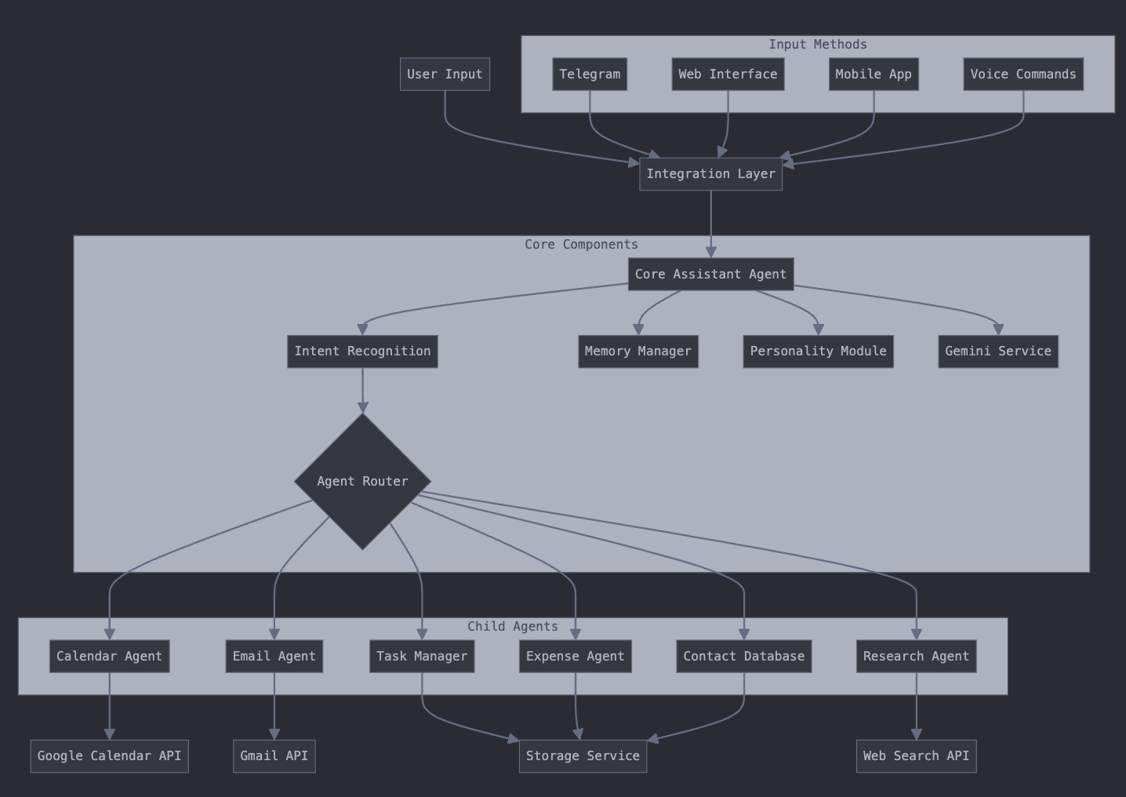

emobot/
├── core/
│ ├── __init__.py
│ ├── assistant_agent.py # Main assistant orchestrator
│ ├── personality.py # emobot personality traits
│ ├── memory_manager.py # Context and conversation memory
│ └── config.py # Configuration settings
│
├── integrations/
│ ├── __init__.py
│ ├── telegram_bot.py # Telegram bot interface
│ ├── web_interface.py # Future web app interface
│ ├── mobile_app.py # Future mobile interface
│ └── voice_interface.py # Voice processing (STT/TTS)
│
├── agents/
│ ├── __init__.py
│ ├── calendar_agent.py # Calendar management
│ ├── email_agent.py # Email handling
│ ├── contact_database.py # Contact management
│ ├── expense_agent.py # Personal expense tracking
│ ├── research_agent.py # Web search and research
│ └── task_manager.py # Todo list management
│
├── services/
│ ├── __init__.py
│ ├── gemini_service.py # Google Gemini API integration
│ ├── speech_service.py # Speech recognition/synthesis
│ ├── storage_service.py # Database/file storage
│ └── file_processor.py # Handle PDF, CSV, etc.
│
├── utils/
│ ├── __init__.py
│ ├── logger.py # Logging utilities
│ ├── auth.py # Authentication helpers
│ ├── validators.py # Input validation
│ └── helpers.py # Common utility functions
│
├── tests/
│ ├── __init__.py
│ ├── test_telegram_bot.py
│ ├── test_agents.py
│ └── test_services.py
│
├── data/
│ ├── memory/ # Conversation history
│ └── user_data/ # User preferences and data
│
├── .env.example # Environment variables template
├── requirements.txt # Python dependencies
├── README.md # Project documentation
├── setup.py # Package setup
└── main.py # Application entry point

